HUMAN RESOURCES IN THE MEDIA: CONTINUOUS EDUCATION AS A KEY TO CONTEMPORARY BUSINESS

Dragana Stefanović
Faculty of Economics and Engineering Management, Novi Sad, Serbia
e-mail: draganavstefanovic@gmail.com

Abstract: The rapidly growing media industry operates under conditions of constant and dynamic change within a highly competitive environment, which constitutes a key prerequisite for its survival and further development. In this context, organizations are increasingly focusing on strategic human resource management, particularly in the areas of recruitment and retention of qualified personnel, as well as on enhancing overall employee productivity. Changes in the contemporary world of work, driven by the development of new technologies, tools, and methodologies, render continuous learning a necessity, as relevant skills quickly lose their currency. At the same time, the achievement of organizational goals requires a workforce capable of adapting to market changes, with human resources management playing a crucial role in anticipating competency gaps and planning training activities. Moreover, continuous education contributes to attracting and retaining talent, as modern employees increasingly value opportunities for professional development and career advancement.
Primary research was conducted to examine the extent to which institutional practices of education and professional development in media organizations contribute to the development of employees’ professional competencies, their adaptability to contemporary professional demands, and their alignment with strategic objectives and professional standards. The research sample was based on purposive sampling and included employees of media organizations in the Republic of Serbia (n = 274). Data were collected between December 2025 and January 2026. The findings demonstrate that continuous education has a dual effect in the media sector: it increases employee motivation and strengthens the capacity of media organizations to adapt to market changes, which has significant implications for strategic human resource management in contemporary media.

Keywords: human resources, media, education, competencies, professional development
Field: Social Sciences
- INTRODUCTION
Continuous education and professional development of employees within the contemporary media system constitute one of the most important segments of human resource management in media organizations. Changes in media content production processes, digital platforms, and the normative framework of media discourse necessitate the ongoing development of professional competencies and the capacity for professional adaptation among media employees. The development of employee competencies, including those of media professionals, is based on the integration of formal, non-formal, and informal learning, implemented through internal educational programs, specialized training, mentoring, and work-based learning. These mechanisms contribute to the enhancement of employees’ technical, analytical, and ethical competencies, as well as to the strengthening of organizational efficiency. In this regard, Becker et al. (2006) observe that major U.S. daily newspapers tend to employ only experienced journalists, suggesting that media organizations will need to invest in training if they wish to ensure that more experienced journalists keep pace with technological advancements.
Contemporary human resource development is shaped by interconnected trends that significantly redefine the role of the HR function. Digitalization and the adoption of HR technologies, including analytics, applicant tracking systems, and employee engagement platforms, enable data-driven decision-making and improve the efficiency of HR processes. At the same time, the growing focus on employee experience, well-being, and work–life balance requires HR professionals to develop a deeper understanding of human behavior and the factors influencing productivity and employee retention. Processes of globalization and the increasing diversity of the workforce further impose the need for the development of cultural competence and the ability to manage complex intercultural relationships. Finally, the integration of artificial intelligence and automation in recruitment, performance management, and training is transforming traditional HR practices and expanding the strategic role of HR professionals (Westover, 2025).

In the contemporary business environment, characterized by accelerated technological change and increasing competition, human resources have become a key driver of organizational efficiency and sustainable competitive advantage. Employees’ knowledge, skills, and adaptive capacity are increasingly recognized as central organizational resources, particularly in information- and creativity-based sectors such as the media. In this context, employee development transcends the framework of occasional training and becomes a strategic component of modern human resource management (Drucker, 1999; Dessler, 2020).
The media industry, confronted with digitalization, media convergence, and transformations in professional roles, is particularly dependent on the continuous enhancement of employees’ knowledge and competencies. Changes in technology, work processes, and relationships with audiences require media professionals to constantly adapt and acquire new skills in order to maintain content quality and professional standards. Research indicates that flexibility, lifelong learning, and professional development have become indispensable elements of work in contemporary media organizations (Deuze, 2007; Castells, 2010; Pavlik, 2013). In this context, continuous education of media employees represents a key mechanism for responding to the structural changes of modern business. It enables not only technological adaptation but also the strengthening of organizational capacities, innovativeness, and the long-term sustainability of media organizations. Contemporary approaches to human resource management therefore emphasize systematic investment in employee education and development as a prerequisite for successful performance in a dynamic and uncertain media environment (OECD, 2019; Dessler, 2020).

- LITERATURE REVIEW

The contemporary, highly dynamic media environment has led to significant changes in the labor market, creating a complex and challenging framework for strategic human resource management in media organizations. At the same time, accelerated technological development imposes the need for continuous and adaptable forms of employee education in order to keep pace with emerging media practices. Finally, the growing role of social media has increased the visibility of both internal and external actors, further affecting organizations’ capacity to manage crisis situations effectively (Costello & Oliver, 2018).
Continuous learning is an integral component of adaptation to constantly evolving trends and technologies. HR professionals must be well acquainted with the latest marketing strategies in order to build a strong workforce capable of meeting contemporary business demands in a globalized and high-technology business environment (Huynh, 2024; Holistique Training, 2023). In this context, continuous improvement and learning are not optional but represent essential elements of human resource management in modern organizations (Rode et al., 2022). Research indicates that organizations investing resources in continuous education experience enhanced workforce flexibility, efficiency, and innovativeness, which is crucial for maintaining competitive advantage in the digital economy (Hasan et al., 2024). A similar argument is advanced by Benabed and Messaoudi (2025), who emphasize that contemporary HR management plays a strategic role in achieving organizational objectives and that continuous employee education is a key factor in fostering flexibility, innovation, and business sustainability. The role of HR professionals is rapidly evolving, requiring continuous education to manage digital transformation and maintain relevance in modern business markets (Zhang & Chen, 2023). Dabić et al. (2023) go a step further by arguing that digitalization has fundamentally transformed the nature of work, making continuous education indispensable for HR in supporting sustainable human resource management. Effective management of human capital through continuous education contributes to the strengthening of organizational culture and overall business efficiency, which is of critical importance for media companies in the contemporary era (Siocon, 2023).

- DATA, METHODOLOGY AND STYLIZED FACTS

The primary research was designed to examine the manner and extent to which institutional practices of education and professional development within media organizations contribute to the development of employees’ professional competencies, their professional adaptability to the contemporary demands of the media profession, and the alignment of these practices with organizational strategic objectives and prevailing professional standards. In this regard, two research hypotheses were formulated:
H₁. Continuous education significantly increases the motivation of media employees.
H₂. Media organizations that invest in employees’ knowledge adapt more easily to market changes.

Data were collected using Google Forms. The research sample was based on purposive sampling and consisted of media employees in the Republic of Serbia. Prior to the construction of the final version of the questionnaire, a pilot study was conducted on a sample of 25 respondents in order to examine the content validity of the measurement instruments used in this research. Based on the results of the pilot study, appropriate revisions were made, after which the final version of the questionnaire was formulated. The main study was then conducted on an independent sample of 274 respondents (n = 274). Data collection was carried out between December 2025 and January 2026.
The questionnaire consisted of three sections. The first section included general questions regarding gender, level of education, age, type of sector in which respondents were employed, work experience in the media, and the position they held within media organizations. In the second section, respondents assessed the significance of continuous education for media employees, while the third section focused on evaluating education and professional development practices in the media organization in which they were employed. For the purposes of statistical processing and data evaluation, methods of descriptive statistics were applied, including measures of central tendency, dispersion, and distribution asymmetry. Non-parametric techniques were used for hypothesis testing. The data were processed using the IBM SPSS software package.

- EMPIRICAL RESULTS AND DISCUSSION
The study sample comprised 274 respondents employed within the media sector. Females were slightly more represented (55.1%) compared to Males (44.9%). In terms of educational attainment, the largest proportion of participants hold a university degree (40.1%), while nearly one-fifth possess a master’s degree (18.2%), and a small minority hold a doctoral degree (PhD) (1.5%). With respect to the type of media, the majority of respondents are employed in television (53.6%), followed by print media (17.9%) and online media (17.2%), whereas radio and news agencies are less represented. Employment is predominantly concentrated in the public sector (90.5%).
Regarding professional experience, most respondents reported more than ten years of work in the media industry (70.1%), indicating a highly experienced sample structure. In terms of organizational position, journalists (35.4%) and editors (27.0%) constitute the largest groups, while technical staff, management, and other positions are less represented. Further details are provided in Table 1. The average age of respondents is 47 years, with a Median of 48 years and a Mode of 44 years.

Table 1 Statistics
 |  | Frequency | Percent | Valid Percent | Cumulative Percent
Gender | Male | 123 | 44.9 | 44.9 | 44.9
Gender | Female | 151 | 55.1 | 55.1 | 100.0
Gender | Total | 274 | 100.0 | 100.0
Level of education | High school | 79 | 28.8 | 28.8 | 28.8
Level of education | Higher school | 31 | 11.3 | 11.3 | 40.1
Level of education | Faculty | 110 | 40.1 | 40.1 | 80.3
Level of education | Master | 50 | 18.2 | 18.2 | 98.5
Level of education | PhD | 4 | 1.5 | 1.5 | 100.0
Level of education | Total | 274 | 100.0 | 100.0
Type of media organization in which you are employed | Print media | 49 | 17.9 | 17.9 | 17.9
Type of media organization in which you are employed | Television | 147 | 53.6 | 53.6 | 71.5
Type of media organization in which you are employed | Radio | 27 | 9.9 | 9.9 | 81.4
Type of media organization in which you are employed | Online media / portal | 47 | 17.2 | 17.2 | 98.5
Type of media organization in which you are employed | News agency | 4 | 1.5 | 1.5 | 100.0
Type of media organization in which you are employed | Total | 274 | 100.0 | 100.0
Employment sector | Public | 26 | 9.5 | 9.5 | 9.5
Employment sector | State sector | 248 | 90.5 | 90.5 | 100.0
Employment sector | Total | 274 | 100.0 | 100.0
Work experience in the media sector | Less than 2 years | 18 | 6.6 | 6.6 | 6.6
Work experience in the media sector | 2–5 years | 27 | 9.9 | 9.9 | 16.4
Work experience in the media sector | 6–10 years | 37 | 13.5 | 13.5 | 29.9
Work experience in the media sector | More than 10 years | 192 | 70.1 | 70.1 | 100.0
Work experience in the media sector | Total | 274 | 100.0 | 100.0
Your position within the media organization | Journalist | 97 | 35.4 | 35.4 | 35.4
Your position within the media organization | Editor | 74 | 27.0 | 27.0 | 62.4
Your position within the media organization | Producer | 10 | 3.6 | 3.6 | 66.1
Your position within the media organization | Technical staff | 39 | 14.2 | 14.2 | 80.3
Your position within the media organization | Management | 38 | 13.9 | 13.9 | 94.2
Your position within the media organization | Other | 16 | 5.8 | 5.8 | 100.0
Your position within the media organization | Total | 274 | 100.0 | 100.0
Source: Authors’ calculation

Only 13.1% of organizations reported that they regularly provide seminars and training programs for their employees, while 46.4% do so occasionally, 30.3% rarely, and 10.2% never.
A chi-square test of independence revealed a statistically significant association between responses to the question “Does your organization provide training programs/seminars for employees?” and the type of media in which respondents are employed, χ²(12, n = 274) = 24.756, p = 0.016, phi= 0.301.
As shown in Table 2 (Crosstabulation), the values of the Adjusted Residuals indicate that employees in print media were significantly less likely than expected to report Yes, regularly (Adjusted Residual = –2.5), while the category Never was significantly more frequent than expected (Adjusted Residual = 3.1). Conversely, for employees in television, the number of cases in the Never category was lower than expected.

Table 2 Crosstabulation
Crosstab
 |  |  | Does your organization provide training programs/seminars for employees? |  |  |  | Total
 |  |  | Yes, regularly | Occasionally | Rarely | Never
Type of media organization in which you are employed | Print media | Count | 1 | 18 | 19 | 11 | 49
Type of media organization in which you are employed | Print media | % within Type of media organization in which you are employed | 2.0% | 36.7% | 38.8% | 22.4% | 100.0%
Type of media organization in which you are employed | Print media | Adjusted Residual | -2.5 | -1.5 | 1.4 | 3.1
Type of media organization in which you are employed | Television | Count | 25 | 70 | 44 | 8 | 147
Type of media organization in which you are employed | Television | % within Type of media organization in which you are employed | 17.0% | 47.6% | 29.9% | 5.4% | 100.0%
Type of media organization in which you are employed | Television | Adjusted Residual | 2.0 | .5 | -.1 | -2.8
Type of media organization in which you are employed | Radio | Count | 3 | 12 | 8 | 4 | 27
Type of media organization in which you are employed | Radio | % within Type of media organization in which you are employed | 11.1% | 44.4% | 29.6% | 14.8% | 100.0%
Type of media organization in which you are employed | Radio | Adjusted Residual | -.3 | -.2 | -.1 | .8
Type of media organization in which you are employed | Online media / portal | Count | 7 | 23 | 12 | 5 | 47
Type of media organization in which you are employed | Online media / portal | % within Type of media organization in which you are employed | 14.9% | 48.9% | 25.5% | 10.6% | 100.0%
Type of media organization in which you are employed | Online media / portal | Adjusted Residual | .4 | .4 | -.8 | .1
Type of media organization in which you are employed | News agency | Count | 0 | 4 | 0 | 0 | 4
Type of media organization in which you are employed | News agency | % within Type of media organization in which you are employed | 0.0% | 100.0% | 0.0% | 0.0% | 100.0%
Type of media organization in which you are employed | News agency | Adjusted Residual | -.8 | 2.2 | -1.3 | -.7
Total |  | Count | 36 | 127 | 83 | 28 | 274
 |  | % within Type of media organization in which you are employed | 13.1% | 46.4% | 30.3% | 10.2% | 100.0%
Source: Authors’ calculation

Within media organizations, the most common form of employee professional development is internal training programs (39.8%), followed by external seminars (19.7%), conferences (16.8%), and self-directed learning (16.4%), while online courses are the least represented (7.3%).
A chi-square test of independence revealed a statistically significant association between the form of professional development and the type of media in which respondents are employed, χ²(16, n=274) = 28.580, p=0.027, phi=0.323. The highest proportion of employees in print media and television (42.9% each) reported participation in internal training programs. Employees in radio were most frequently engaged in external seminars, whereas those in news agencies were equally represented in external seminars and conferences (50% each). Online courses were reported only by employees in print media (14.3%) and online media/portals (12.8%), while in other media organizations they were negligibly represented.
Respondents evaluated the statement “Continuous education increases employee motivation” with an average score of 5.62, a median of 6, and a mode of 6. The first quartile (Q1) was 5, indicating that 25% of respondents rated the statement with 5 or lower, while the third quartile (Q3) was 7. The variable demonstrated relatively low variability (CV=26.71%) and strong negative skewness (Skewness=–1.102). This view was consistently expressed across gender, educational levels, organizational positions, employment sectors, and years of professional experience in the media. Among respondents who rated the statement with 5 or higher, the most frequently cited reason was “New knowledge increases confidence and self-assurance in job performance” (44%), followed by “Additional education creates a sense of personal and professional advancement” (34.67%), and “Employees feel valued when employers invest in their knowledge” (21.3%).

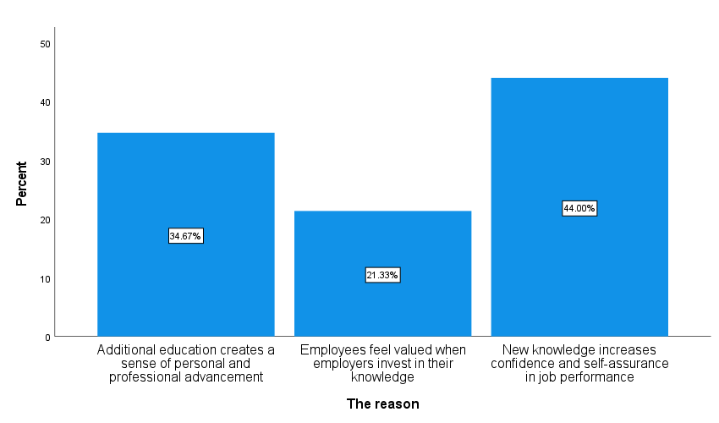
Graph 1 Reasons for the positive impact of continuous education on motivation
Source: Authors’ calculation

Respondents evaluated the statement “Media organizations that invest in knowledge adapt more easily to market changes” with a very high average score of 6.06, a Median of 6, and a Mode of 7. The variable exhibited strong negative skewness (Skewness=–1.521) and relatively low variability (CV=19.75%). This view was consistently expressed across gender, educational levels, organizational positions, employment sectors, and years of professional experience in the media. Among respondents who rated the statement with a score of 5 or higher, the most frequently cited reason was “Knowledge enables more efficient implementation of new business and technological models” (44%), followed by “The organization becomes more flexible and better prepared for competitive challenges” (30.8%), and “Employees respond more quickly to changes in audience and market needs” (25.2%).
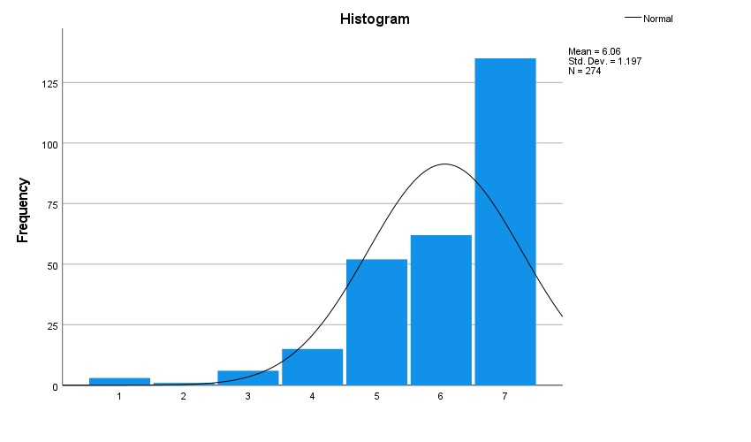
Graph 2 Assessment of the statement “Media organizations that invest in knowledge adapt more easily to market changes”
Source: Authors’ calculation
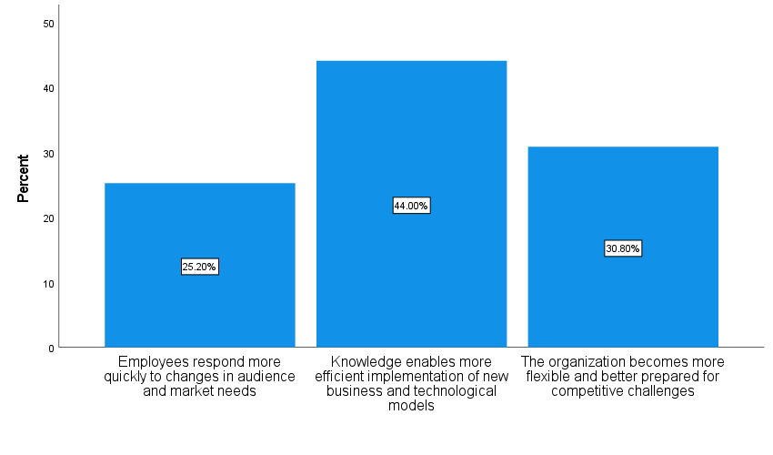
Graph 1 Reasons for the positive impact of investment in knowledge on adaptation to market changes
Source: Authors’ calculation

A strong linear relationship was observed between the items “Continuous education increases employee motivation” and “Media organizations that invest in knowledge adapt more easily to market changes”, with a correlation coefficient of r=0.714. Furthermore, significant linear associations were found between “Training programs and seminars improve the professional skills of employees” and “Continuous education increases employee motivation” (r=0.586), as well as between “Training programs and seminars improve the professional skills of employees” and “Media organizations that invest in knowledge adapt more easily to market changes” (r=0.579).
Table 3 Correlations
 | 1 | 2 | 3 | 4
1. Continuous education is essential for high-quality work in contemporary media | -
2. Training programs and seminars improve the professional skills of employees | .424** | -
3. Continuous education increases employee motivation | .393** | .586** | -
4. Media organizations that invest in knowledge adapt more easily to market changes | .412** | .579** | .714** | -
**. Correlation is significant at the 0.01 level (2-tailed).
Source: Authors’ calculation

- CONCLUSION
This research study contributes to the development of future directions in human resource education within the media sector by identifying potential trends, emerging best practices, and key competencies required of media professionals in the contemporary digital environment. Particular emphasis is placed on a strategic approach to business operations, as well as on competencies of critical importance for the planning, implementation, and evaluation of training programs, grounded in an interdisciplinary approach and the principles of continuous professional development. In the context of accelerated and profound transformations of the media landscape, the need for new, innovative, and creative human resources is becoming increasingly pronounced. The research findings indicate that training and professional development programs in media organizations remain insufficiently systematic, as only 13.1% of organizations regularly organize seminars and training activities, while in the majority of cases such programs are implemented occasionally or rarely. Nevertheless, a statistically significant association between the frequency of training provision and the type of media confirms that the institutional approach to employee education depends on the media sector. These results demonstrate that the structural characteristics of media organizations influence employees’ educational practices. A significant relationship was also identified between the forms of employee professional development and the type of media, further confirming that different media sectors adopt different models of knowledge development. Internal training represents the most common form of professional development, particularly in print and television media, whereas external education programs and conferences are more characteristic of radio stations and news agencies. Online courses are poorly represented and largely limited to print and online media, indicating the underutilized potential of digital learning formats.
Regarding respondents’ attitudes, continuous education received a high mean score of 5.62, with a strong level of agreement among respondents regardless of gender, educational background, job position, employment sector, or work experience. The most significant reasons underlying this perception relate to increased self-confidence gained through new knowledge, a sense of professional advancement, and the perception of being valued by the organization. This pattern of responses clearly indicates that continuous education has a strong motivational effect on media employees, thereby confirming Hypothesis H1. The statement that media organizations investing in employees’ knowledge are better able to respond to market changes was rated with a very high mean score of 6.06, accompanied by low variability and a high degree of consensus across all sociodemographic and professional categories of respondents. Key reasons include more effective implementation of new business and technological models, greater organizational flexibility, and faster responses to changes in audience needs and market conditions. These findings clearly demonstrate that investment in knowledge represents an important mechanism of adaptability for media organizations, thus confirming Hypothesis H2.

LITERATURE
Becker, L., Vlad, T., & Martin, H. (2006). Change and Stability in the Newspaper Industry's Journalistic Labor Market. International Journal on Media Management, 8:1, 39-49.
Benabed, F., & Messaoudi, B. (2025). The role of contemporary human resource management in improving companies organizational performance. Pegem Journal of Education and Instruction, 15(4), 1872-1888.
Castells, M. (2010). The rise of the network society (2nd ed.). Wiley-Blackwell.
Costello, J. and Oliver, J.J. (2018). Human Resource Management in the Media. Handbook of Media Management and Economics (Media Management and Economics Series), Chapter 7, 95-110, Routledge.
Dabić, M., Frances Maley, J., Švarc, J., & Poček, J. (2023). Future of digital work: Challenges for sustainable human resource management, 8(2),1-9. Journal of Innovation & Knowledge. https://doi.org/10.1016/j.jik.2023.100353
Dessler, G. (2020). Human resource management (16th ed.). Pearson.
Deuze, M. (2007). Media work. Polity Press.
Drucker, P. F. (1999). Management challenges for the 21st century. HarperBusiness.
Hasan, M., Haque, A., Sharmin Nishat, S., & Hossain, M. (2024). Upskilling and Reskilling in a Rapidly Changing Job Market: Strategies for Organizations to Maintain Workforce Agility and Adaptability. European Journal of Business and Management Research, 9(6), 118-126. https://doi.org/10.24018/ejbmr.2024.9.6.2502
Holistique Training. (2023, June 1). The importance of HR marketing: Building a strong workforce. Retrieved from https://holistiquetraining.com/en/news/the-importance-of-hr-marketing-building-a-strong-workforce
Huynh, M. S. (2024). Human resources in the knowledge economy: Training and developing modern management skills. International Journal of Multidisciplinary Research and Analysis, 7(7), 3260–3268.
https://doi.org/10.47191/ijmra/v7-i07-25
Organisation for Economic Co-operation and Development (OECD). (2019). Getting skills right: Future-ready adult learning systems. OECD Publishing. https://doi.org/10.1787/9789264311756-en
Pavlik, J. V. (2013). Innovation and the future of journalism. Columbia University Press.
Rode, J. C., Huang, X., & Roge, R. (2022). Human resources practices and continuous improvement and learning across cultures. Journal of International Management, 28(4), 100972.
https://doi.org/10.1016/j.intman.2022.100972
Siocon, G. (2023). Why is human resources important? 8 top reasons. Academy to Innovate HR. Retrieved from https://www.aihr.com/blog/why-is-human-resources-hr-important/
Westover, J. H. (2025). The Future of HR Education. Human Capital Leadership Review, 17(3).
https://doi.org/10.70175/hclreview.2020.17.3.1.2
Zhang J, & Chen Z. (2023). Exploring Human Resource Management Digital Transformation in the Digital Age. Journal of the Knowledge Economy, 15, 1482-1498. https://doi.org/10.1007/s13132-023-01214-y

